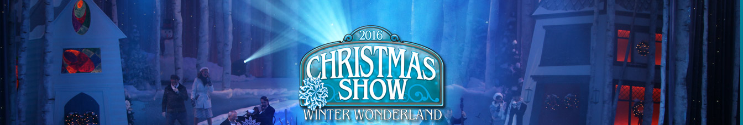
Saturday, December 2nd, 2017
Showtime: 10:30 am – 12:45 pm
Bus Leaves Catty High School at 8:00 am Sharp
Lunch at Shady Maples Smorgasbord
1:30 pm to 3:30 pm
Return to Catty High School at 5:30 pm
Prices:$95.00 per person
$50.00 Deposit Per Person
Required At Time Of Reservation..
For reservation form click here…
For more information please contact
Chuck at 610-262-7961 x306

